**DAILY ONLINE ACTIVITIES SUMMARY**

|  |  |  |  |  |  |  |  |
| --- | --- | --- | --- | --- | --- | --- | --- |
| **Date:** | **16/06/2020** | | | | **Name:** | **Sannidhi P** | |
| **Sem & Sec** | **8th B** | | | | **USN:** | **4AL16C084** | |
| Online Test Summary | | | | | | | |
| **Subject** | | **BDA** | | | | | |
| **Max. Marks** | | **30** | | **Score** | | **18** | |
| Certification Course Summary | | | | | | | |
| **Course** | **SOLOLEARN** | | | | | | |
| **Certificate Provider** | | | **JAVASCRIPT Tutorial** | **Duration** | | | **2hrs** |
| Coding Challenges | | | | | | | |
| **Problem Statement:**  1) Python rogram to find the SHA-1 message digest of a file | | | | | | | |
| **Status: Solved** | | | | | | | |
| **Uploaded the report in Github** | | | | **YES** | | | |
| **If yes Repository name** | | | | **Samrinbanu** | | | |
| **Uploaded the report in slack** | | | | **YES** | | | |

Online test:

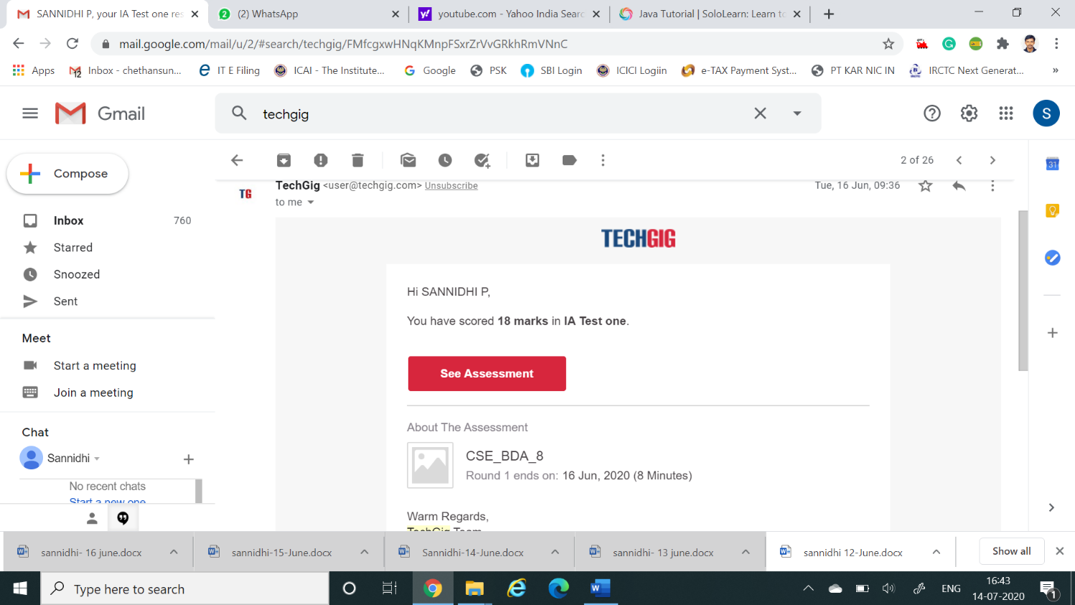

**Certification Course Details:**

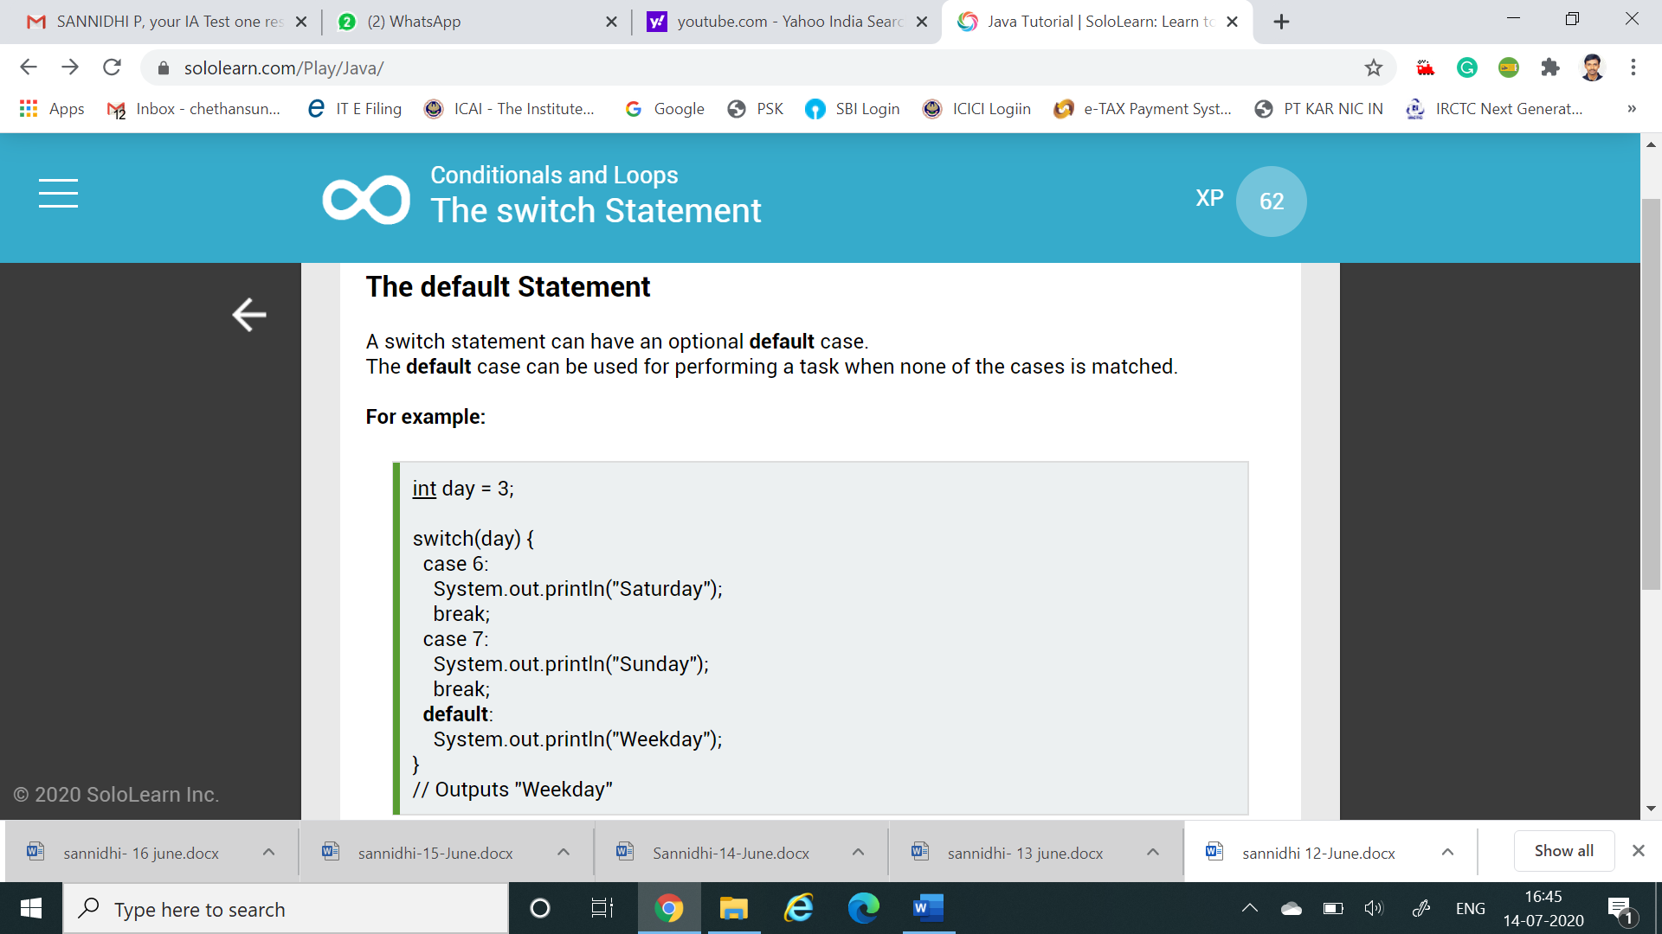

# CODE:

Program no:1

# Python rogram to find the SHA-1 message digest of a file

# importing the hashlib module

import hashlib

def hash_file(filename):

""""This function returns the SHA-1 hash

of the file passed into it"""

# make a hash object

h = hashlib.sha1()

# open file for reading in binary mode

with open(filename,'rb') as file:

# loop till the end of the file

chunk = 0

while chunk != b'':

# read only 1024 bytes at a time

chunk = file.read(1024)

h.update(chunk)

# return the hex representation of digest

return h.hexdigest()

message = hash_file("track1.mp3")

print(message)